**Abdelfatah TAOUALA**

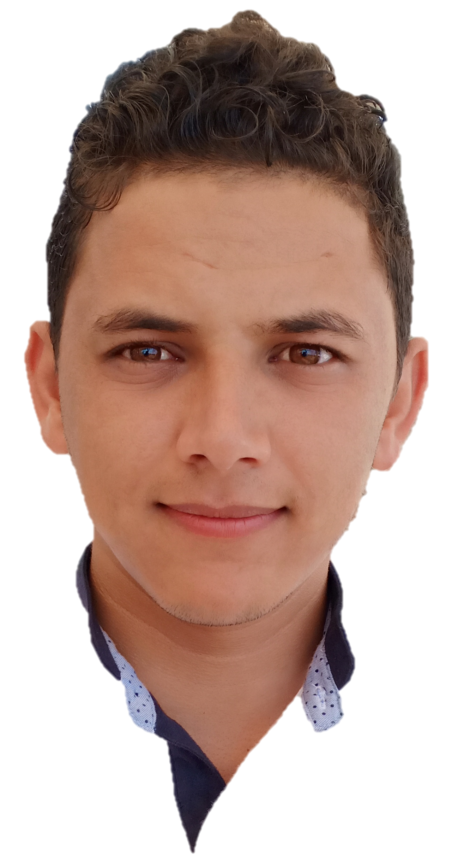

[Abdotaouala@gmail.com](mailto:Abdotaouala@gmail.com)

+21252637020

Casablanca, MOROCCO

Full-stack developer

**ReactJs - Angular - Spring**

Professional experiences

04/2019 - Now : **Full-stack developer (ReactJS // Spring).**

Company: Maltem Consulting Group external at BCP Bank

Project: ‘MaRetraite’ new simulator and manager of savings contracts

within the ChaabiNet platform.

* Development of web interfaces and consumption of REST APIs in Front-end (React, PrimReact Thunk, Axios, Redux).
* Implementation insurance algorithms (JavaScript, Java 8)
* REST API development with spring boot.
* Data synchronization using microservices architecture (Java 8, RestTemplate).
* of the data persistence with JPA / Hibernate, SQL / PLSQL
* Unit testing with JUnit and Mockito, EnzymeJs.
* Code reviews / Technical reference.
* Continuous Integration, Continuous Deployment with GitLab CI / CD.

Sector: Banking / Insurance.

Tools : ReactJs, Redux, Spring, Java 8, GitFlow, GitLab, Jenkins, Scrum/Agile, GitLab CI / CD, SonarLint, Jira.

06/2018 – 04/2019 : **Full-stack developer** **(Angular // Spring).**

Company: Berexia Consulting external at Scor

Project: FDC (Flexible Data Capture) advanced calculator to estimate the reimbursement of bodily injuries.

* Development of web interfaces and consumption of REST APIs in Front-end (Angular, PrimeNg, Materialize, Bootstrap, Redux NgXs).
* Implementation of insurance algorithms (TypeScript, Java 8)
* REST API development with spring boot
* Management of the data persistence with JPA / Hibernate, SQL / PLSQL,
* Database continuous integration with DropOps.
* Unit testing with JUnit and Mockito, JasmineJs.
* Continuous Integration, Continuous Deployment with Jenkins.

Sector: Insurance

Tools: Angular, Redux, Spring, Java 8, Jenkins, Jira, Slack, Scrum/Agile.

06/2018 - 04/2019: **Front-end Developer (Angular // DeepStrem // FireBase)**

Company: DevCorp external at SJL Group

Project: Front office of OnTrack, a modern Transport Management

System (TMS)

* Development of web interfaces and consumption of REST APIs in Front-end (Angular, PrimeNg, Bootstrap).
* Integration of real-time maps to track vehicles locations (DeepStream, FireBase).
* Unit testing JasmineJs.
* Versioning and code quality Git, GitHub, GitFlow, TsLint.

Sector: Transport / Logistics

Tools: Angular, DeepStream, Firebase, AmChart, google map, ReadMine.

04/2016 - 05/2017 : **Front-end developer (ReactJs // HTML // CSS // Bootstrap)**

Company : Amaynotech external at Hightof

Project: Front office to manage the tennis ball launchers HIGHTOF

* Development of web interfaces and consumption of REST APIs in Front-end (React, PrimeReact, RequestJs).
* Versioning and code quality Git, GitHub, GitFlow, SonarLint.

Sector: Sport

Tools: HTML, CSS, Bootstrap, Trello, Slack, ReactJs, GitHub.

Computer skills

Front-end : Angular (1,2,4,6) , ReactJS.

Back-end Framework : Spring.

Realtime : DeepStream, Firebase.

Libraries : Google Map, Bootstrap, PrimeFaces, PrimeReact, AngularMaterialize, UnderScorJs, loadashJs.

Unit testing : Junit, Mockito, EnzimeJs, JasmineJS

Versioning : GIT, GitHub, GitLab.

Code quality : SonarQube, SonarLint, TsLint, JsLint

Programing language : Java 8, TypeScript, JavaScript (ES5, ES6), SQL, PL/SQL.

DataBase : Oracle, SQL Server, MySQL, ElasticSearch, MongoDB.

DevOps Tools ; Jenkins, DropOps, GitLab CI / CD, Docker.

Education

2016 - 2018: **Master Degree of Distributed IT Systems**

UNIVERSITY Hassan II Higher School of Technical Education OF

Mohammedia (MOROCCO).

2013 - 2016: **BACHELOR OF technologies and web development.**

UNIVERSITY CADI AAYAD FACULTY OF SCIENCE SEMLALYA OF MARRAKECH (MOROCCO)